Name: | Lekh Sanatan Nayak
UID: | 2023800068
Experiment No. | 4

AIM:
Program 1
PROBLEM STATEMENT : | Exercise GradesStatistics : Write a program called GradesStatistics, which reads in n grades (of int between 0 and 10, inclusive) and displays the average, minimum, maximum, median and standard deviation. Display the floating-point values upto 2 decimal places. Your output shall look like:  Enter the number of students : 4  Enter the grade for students 1 : 50  Enter the grade for students 1 : 51  Enter the grade for students 1 : 56  Enter the grade for students 1 : 53  {50,51,56,53}  The average is 52.50  The Minimum is 50  The Maximum is 56  The Median is : 52.00  Note: 1) The std. deviation is 2.29(formula can be referred from net)
PROGRAM: | import java.util.*;  //Creating a class GradesStatistics  public class GradesStatistics {  public static void main (String[] args) {  Scanner sc = new Scanner(System.in);  // Prompt the user to enter the number of students  System.out.println("Enter the number of students:-");  int num = sc.nextInt();  // Create an array to store the grades entered by the user  double grades[] = new double[num];  // Loop through each student and prompt the user to enter their grade  for (int i = 0; i < num ; i++) {  System.out.println("Enter grade for student " + (i + 1) +" :");  grades[i] = sc.nextDouble(); // Read the grade entered by the user  }  // Print out the grades entered by the user  System.out.println(Arrays.toString(grades));  // Calculate and print the average of the grades  System.out.printf("Average is %.2f\n", calculateAvg(grades));  // Calculate and print the minimum grade  System.out.printf("Minimum grade is %.2f\n", calculateMin(grades));  // Calculate and print the maximum grade  System.out.printf("Maximum grade is %.2f\n", calculateMax(grades));  // Calculate and print the median grade  System.out.printf("Median grade is %.2f\n", calculateMedian(grades));  // Calculate and print the standard deviation of the grades  System.out.printf("Standard Deviation is %.2f\n", calculateStdDev(grades));  }  // Method to calculate the average of grades  public static double calculateAvg (double[] grades) {  double sum = 0;  // Loop through each grade and calculate the sum  for (double grade:grades) {  sum +=grade;  }  // Calculate and return the average by dividing the sum by the number of grades  return sum/grades.length;  }  // Method to calculate the minimum grade  public static double calculateMin (double[] grades) {  double min = grades[0];  // Loop through each grade to find the minimum  for (double grade:grades) {  if (grade < min) {  min = grade;  }  }  return min;  }  // Method to calculate the maximum grade  public static double calculateMax (double[] grades) {  double max = 0;  // Loop through each grade to find the maximum  for (double grade:grades) {  if (grade > max) {  max = grade;  }  }  return max;  }  // Method to calculate the median grade  public static double calculateMedian (double[] grades) {  Arrays.sort(grades); // Sort the grades array  int len = grades.length;  // If the number of grades is even, return the average of the two middle grades  if (len % 2 == 0) {  return (grades[len/2] + grades[(len/2) - 1]) / 2;  }  // If the number of grades is odd, return the middle grade  else {  return grades[len/2];  }  }  // Method to calculate the standard deviation of grades  public static double calculateStdDev (double[] grades) {  double ssd = 0; // Sum of squared differences  double variance = 0;  // Loop through each grade and calculate the sum of squared differences from the mean  for (int i = 0; i < grades.length; i++) {  ssd += Math.pow((grades[i] - calculateAvg(grades)), 2);  }  variance = ssd / grades.length; // Calculate the variance  // Calculate the standard deviation by taking the square root of the variance  return Math.sqrt(variance);  }  }
RESULT:
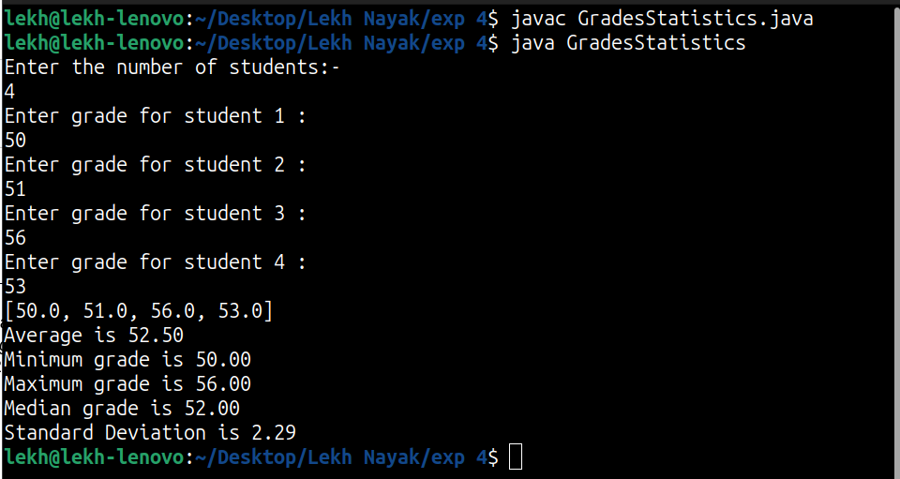
Program 2
PROBLEM STATEMENT : | Book Ratings : Write a program to find the most popular book.  Create a 2D array named bookRating which should hold ratings( 1 to 5) of a few books. Collect ratings of n such books. a)Find the average rating of each book. b) Display the most popular book. i.e. a Book with highest average rating.
PROGRAM: | import java.util.*;  public class BookRatings {  public static void main(String[] args) {  Scanner scanner = new Scanner(System.in);  // Prompting the user to enter the number of books  System.out.print("Enter the number of books: ");  int numBooks = scanner.nextInt(); // Getting the number of books  // Prompting the user to enter the number of reviewers  System.out.print("Enter the number of reviewers: ");  int numReviewers = scanner.nextInt(); // Getting the number of reviewers  // Creating a 2D array to store ratings for each book by each reviewer  int[][] bookRating = new int[numBooks][numReviewers];  // Getting ratings for each book from each reviewer  for (int i = 0; i < numBooks; i++) {  System.out.println("Enter the ratings for book " + (i + 1) + ":");  for (int j = 0; j < numReviewers; j++) {  bookRating[i][j] = scanner.nextInt(); // Storing ratings in the 2D array  }  }  // Calculating average ratings for each book  double[] averageRatings = calculateAverageRatings(bookRating);  // Finding the index of the most popular book based on the highest average rating  int mostPopularBookIndex = findMostPopularBook(averageRatings);  // Displaying the results  displayResults(averageRatings, mostPopularBookIndex);  }  // Method to calculate average ratings for each book  public static double[] calculateAverageRatings(int[][] bookRating) {  double[] averageRatings = new double[bookRating.length];  for (int i = 0; i < bookRating.length; i++) {  double sum = 0;  for (int rating : bookRating[i]) {  sum += rating; // Calculating the sum of ratings for each book  }  averageRatings[i] = sum / bookRating[i].length; // Calculating the average rating for each book  }  return averageRatings; // Returning array of average ratings for each book  }  // Method to find the index of the most popular book  public static int findMostPopularBook(double[] averageRatings) {  int mostPopularBookIndex = 0;  double highestAverageRating = averageRatings[0];  for (int i = 1; i < averageRatings.length; i++) {  if (averageRatings[i] > highestAverageRating) {  highestAverageRating = averageRatings[i];  mostPopularBookIndex = i; // Updating index of the most popular book  }  }  return mostPopularBookIndex; // Returning index of the most popular book  }  // Method to display results  public static void displayResults(double[] averageRatings, int mostPopularBookIndex) {  // Displaying the average ratings of all books  System.out.println("The average ratings of all books given are :");  for (int i = 0; i < averageRatings.length; i++) {  System.out.printf("Book no %d has average rating: %.2f\n", (i + 1), averageRatings[i]);  }  // Displaying the best book with its average rating  System.out.println("The best book is book no " + (mostPopularBookIndex + 1) + " with an average rating of: " + averageRatings[mostPopularBookIndex]);  }  }
RESULT:
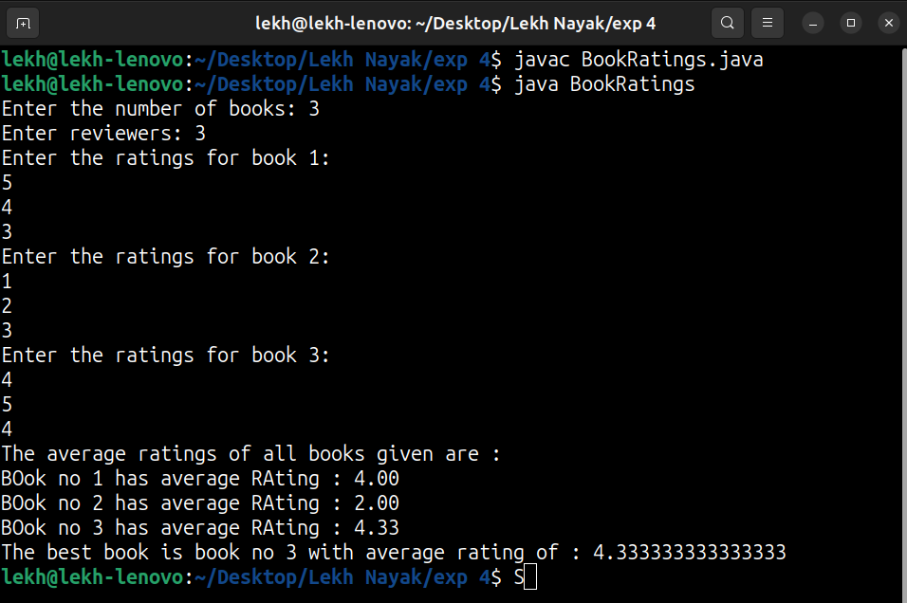
Program 3
PROBLEM STATEMENT: | Your country is at war and your enemies are using a secret code to communicate with each other. You have managed to intercept a message that reads as follows:  :mmZ\dxZmx]Zpgy  The message is obviously encrypted using the enemy’s secret code. You have just learned that their encryption method is based upon the ASCII code.  For example, the letter “A” is encoded using the number 65 and “B” is encoded using the number 66.  Your enemy’s secret code takes each letter of the message and encrypts it  as follows:  If (OriginalChar + Key > 126) then  EncryptedChar = 32 + ((OriginalChar + Key) – 127)  Else  EncryptedChar = (OriginalChar + Key)  For example, if the enemy uses Key = 10 then the message “Hey” would be  encrypted as:  Character ASCII code  ______________________  H 72  e 101  y 121  Encrypted H = (72 + 10) = 82 = R in ASCII  Encrypted e = (101 + 10) = 111 = o in ASCII  Encrypted y = 32 + ((121 + 10) – 127) = 36 = $ in ASCII  Consequently, “Hey” would be transmitted as “Ro$.”  Write a program that decrypts the intercepted message. You only know that the key used is a number between 1 and 100. Your program should try to decode the message using all possible keys between 1 and 100.  When you try the valid key, the message will make sense. For all other keys, the message will appear as gibberish.
PROGRAM: | import java.util.*;  import java.lang.*;  public class morse {  public static void main(String[] args) {  // The encrypted message to be decrypted  String encryptedMessage = ":mmZ\\dxZmx]Zpgy";  // Loop through possible keys from 1 to 100 to decrypt the message  for (int key = 1; key <= 100; key++) {  String decryptedMessage = decrypt(encryptedMessage, key);  // Print the decrypted message along with the key used for decryption  System.out.println("Decryption : " + key + ": " + decryptedMessage);  }  }  // Method to decrypt the message using a given key  public static String decrypt(String encryptedMessage, int key) {  StringBuilder decrypted = new StringBuilder();  // Iterate through each character in the encrypted message  for (int i = 0; i < encryptedMessage.length(); i++)  {  // Get the character at index i  char encryptedChar = encryptedMessage.charAt(i);  char decryptedChar;  // Decrypt the character using the key  if (encryptedChar - key < 32)  {  // If the decrypted character falls below ASCII 32, wrap around from ASCII 127  decryptedChar = (char) (127 - (32 - (encryptedChar - key)));  }  else  {  // Decrypt the character normally  decryptedChar = (char) (encryptedChar - key);  }  // Append the decrypted character to the StringBuilder  decrypted.append(decryptedChar);  }  // Convert the StringBuilder to a String and return the decrypted message  return decrypted.toString();  }  }
RESULT:
Program 4
PROBLEM STATEMENT: | Write a program in Java to maintain the information of Movies which includes the information of name of movie , type of movie( action , thriller , comedy ,drama ) , Hero name , Heroine , budget in Rs. . Write a program to accept the information of movies from user and sort them according to the budget of the film.
PROGRAM: | import java.util.*;  // Define a class to represent a Movie  class Movie {  String name;  String type;  String heroName;  String heroineName;  double budget;  // Constructor to initialize Movie object  Movie(String name, String type, String heroName, String heroineName, double budget) {  this.name = name;  this.type = type;  this.heroName = heroName;  this.heroineName = heroineName;  this.budget = budget;  }  // Override toString() method to provide custom string representation of Movie object  public String toString() {  return "Movie: " + name + ", Type: " + type + ", Hero: " + heroName + ", Heroine: " + heroineName + ", Budget: Rs. " + budget;  }  }  public class MovieInformation {  public static void main(String[] args) {  Scanner scanner = new Scanner(System.in);  List<Movie> movies = new ArrayList<>();  // Accepting information of movies from the user  System.out.println("Enter the number of movies:");  int numMovies = scanner.nextInt();  scanner.nextLine(); // consume newline  // Loop to gather information for each movie  for (int i = 0; i < numMovies; i++) {  System.out.println("Enter details for movie " + (i + 1) + ":");  System.out.print("Name: ");  String name = scanner.nextLine();  System.out.print("Type (action, thriller, comedy, drama): ");  String type = scanner.nextLine();  System.out.print("Hero Name: ");  String heroName = scanner.nextLine();  System.out.print("Heroine Name: ");  String heroineName = scanner.nextLine();  System.out.print("Budget in Rs.: ");  double budget = scanner.nextDouble();  scanner.nextLine(); // consume newline  // Create a Movie object and add it to the list  Movie movie = new Movie(name, type, heroName, heroineName, budget);  movies.add(movie);  }  // Sorting movies according to budget using Collections.sort() and a custom Comparator  Collections.sort(movies, new Comparator<Movie>() {  // Custom comparator to compare movies based on their budget  public int compare(Movie m1, Movie m2) {  return Double.compare(m1.budget, m2.budget);  }  });  // Displaying sorted movies  System.out.println("\nMovies sorted by budget:");  for (Movie movie : movies) {  System.out.println(movie);  }  // Close the scanner to release resources  scanner.close();  }  }
RESULT:
CONCLUSION:

